Assess for:
Upper airway obstruction
(stridor, oral swelling) or
Lower airway obstruction (wheeze, respiratory distress) or
Shock
(dizziness, pale, clammy)

Call for help
Remove trigger / causative agent
Position flat or sitting, not walking or standing

NO Cardiac arrest?
YES

Adrenaline IM

Use auto injector if available (preferred injection site upper outer thigh)
Adults: 0.5mg (0.5ml of 1:1,000) Children: 10mcg/kg (0.01mL/kg of 1:1,000)

(min dose 0.1mL, max dose 0.5mL)
Repeat every 5 minutes as needed

Refer Advanced Life Support algorithm

Attach cardiac monitoring
High flow oxygen
IV access
For shock:
0.9% saline rapid infusion Adults: 1,000mL Children: 20mL/kg

RESOLUTION

Observe (4 hours min)
Monitor vital signs, reassess ABC Consider steroids and oral
antihistamine

Call for specialist advice Consider:

- 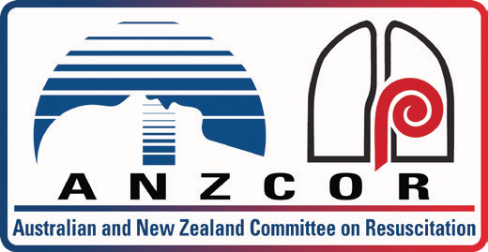Transfer to advanced care setting
January 2019
Anaphylaxis
- Further 0.9% saline
- Nebulised adrenaline for upper airway obstruction
- Adrenaline infusion
- Inotropic support
- Nebulised salbutamol for lower airway obstruction

